Rainbow of Me
- Color the first stripe of the rainbow the color of your eyes
- Color the next stripe your favorite color
- Color the next stripe the color of your favorite thing to eat
- Color the next stripe the color of your favorite thing to smell
- Color the next stripe the color of your favorite thing to play with
- Color the next step a color that shows how you feel right now
- Color one cloud a color that reminds you of feeling safe
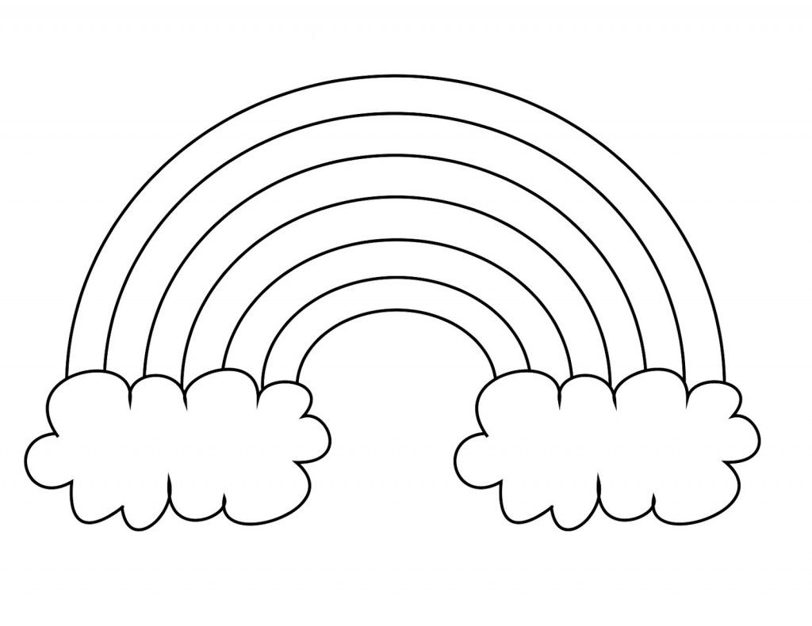
- Color the other cloud a color that reminds of feeling loved

