Do you need assistance with school supplies for classes this fall?
The BACK TO SCHOOL PROJECT is here to help.

Our mission is to provide new school supplies to families in the Cedar Valley who need assistance, so that students will have the proper supplies to start school in the fall. Applications are required for students to receive supplies.
Applications will be taken at the Waterloo Community Schools headquarters. School supplies will be available for students in Kindergarten through Middle School.

Applications will be taken from July 5 through August 4th. Hours are 9:00 AM - 4:30 PM on Monday through Friday. Supplies will be available August 17th and 18th.

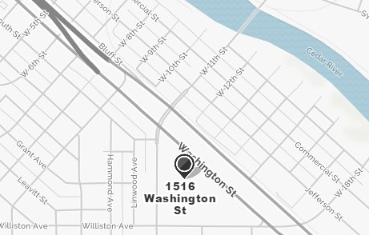
The Waterloo Community Schools headquarters is located at 1516 Washington St, Waterloo.
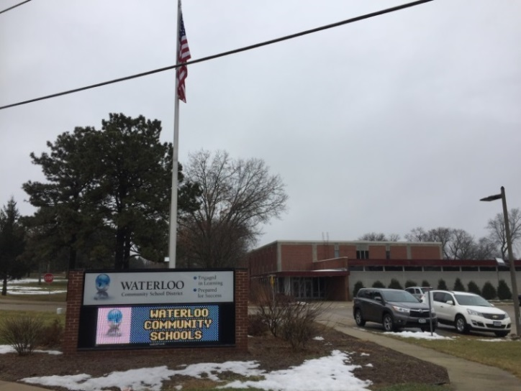
For answers to all questions, call Ruth at 319-240-7470.

Information needed to apply
Last Name, First Name of person responsible to pick up supplies.
A contact Phone Number
Children’s first name
BACK TO SCHOOL PROJECT
PO Box 2334
Waterloo, IA 50704
Ruth Orth 319-240-7470
RNLComp@mchsi.com
Web site: btscedarvalley.org
Children’s school
Children’s grade
Is child a boy or a girl

